Git delete a file that has been added to git already

Summary

Go to the particular directory that you want to exclude from git.

Right click on it:

TortoiseGit

Delete (keep local)

Remove

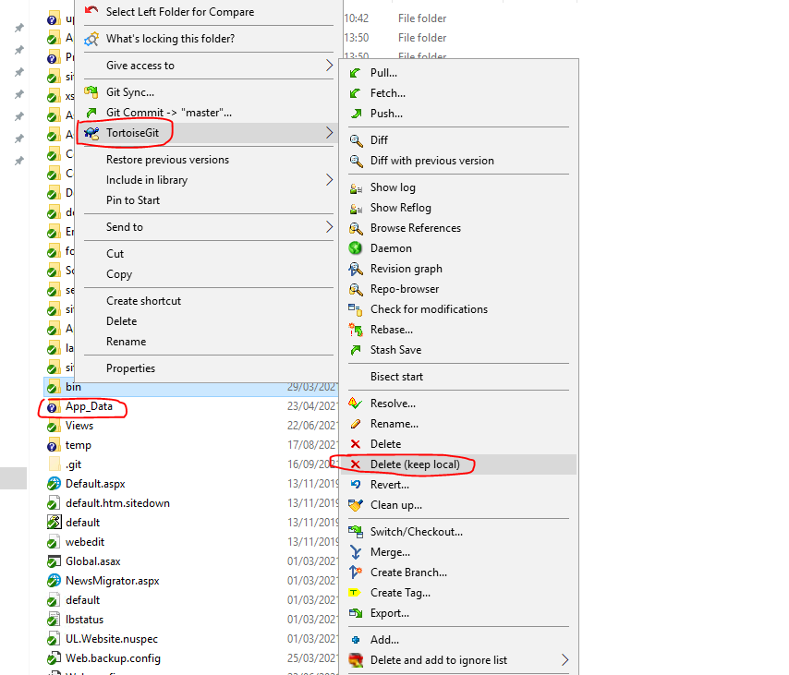

2. The file/folder will still exist locally however it has been removed from git.



3. The next step is to right click in the folder:

– TortoiseGit;

– Check for modifications

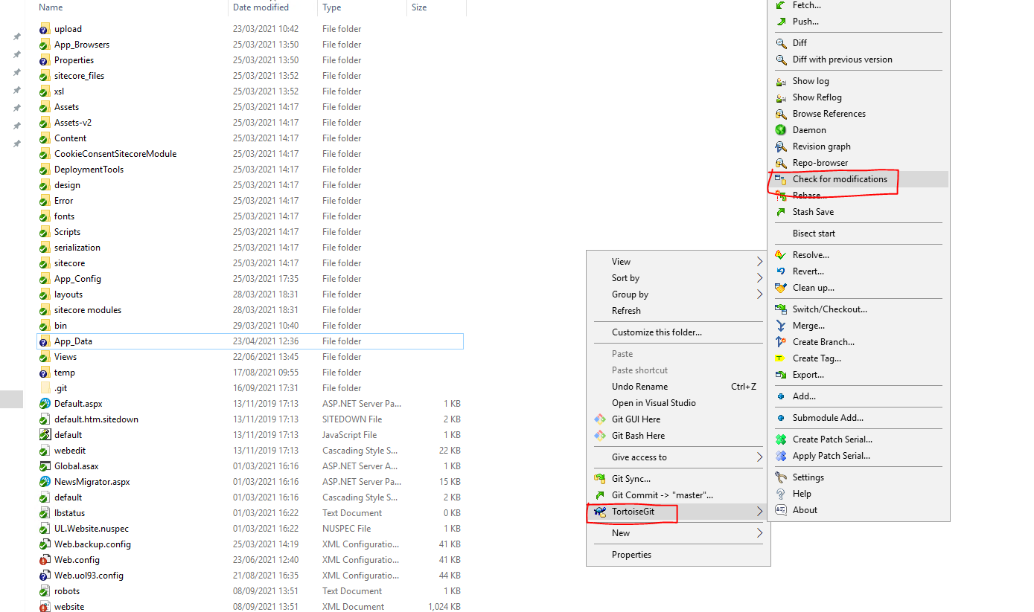

4. You will see the below pop-up window:

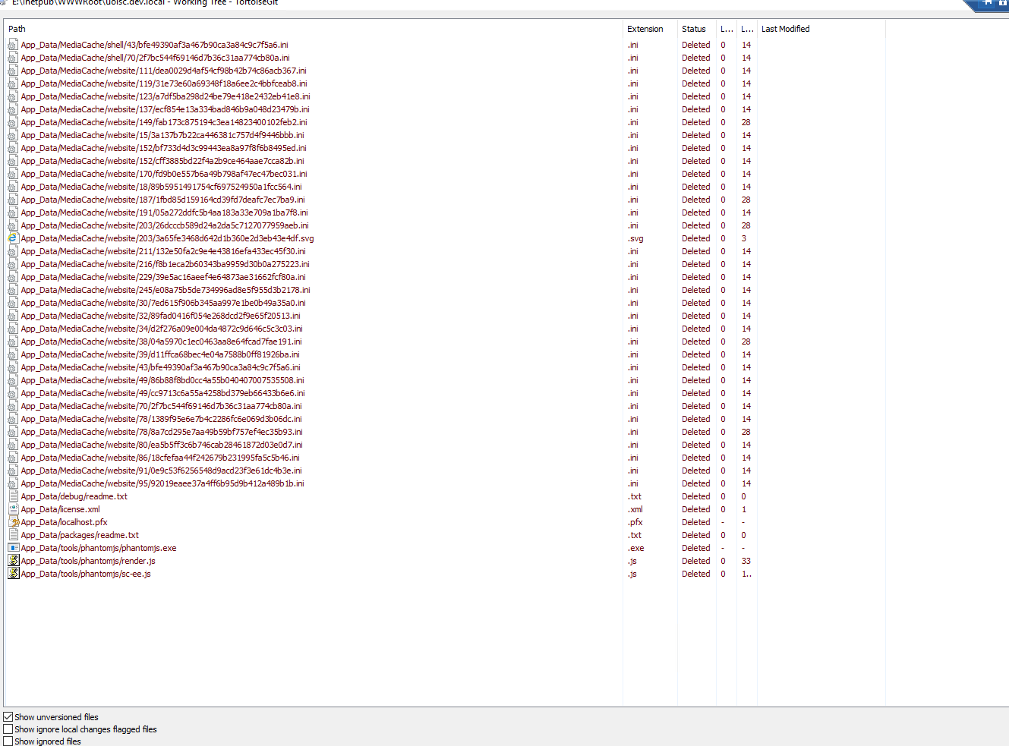

5. The final step is to commit the files which have a status of Deleted.

Right click in the directory and go to Git Commit -> “master”

